Scaffolding is a technique used by many MVC frameworks like ASP.NET MVC, Ruby on Rails, Cake PHP and Node.JS etc., to generate code for basic CRUD (create, read, update, and delete) operations against your database effectively. Further you can edit or customize this auto generated code according to your need.

Scaffolding consists of page templates, entity page templates, field page templates, and filter templates. These templates are called Scaffold templates and allow you to quickly build a functional data-driven Website.

**How Scaffold templates works in ASP.NET MVC..**

Scaffold templates are used to generate code for basic CRUD operations within your ASP.NET MVC applications against your database with the help Entity Framework. These templates use the Visual Studio T4 templating system to generate views for basic CRUD operations with the help of Entity Framework.

**Steps to create ASP.NET MVC CRUD operations using scaffolding**

1. Adding controller to your project

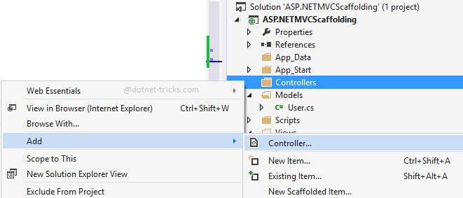

1. Choosing a scaffold template for creating CRUD operations

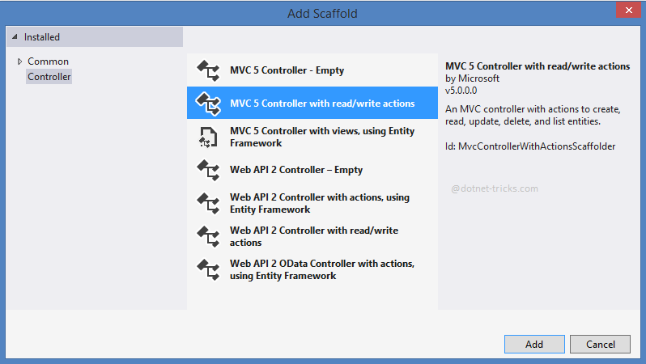

1. Provide a name to your controller

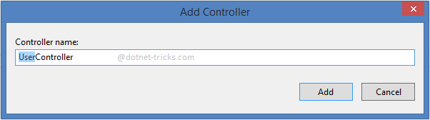

The following actions are created for insert, update and delete operations based on scaffold template within User controller.

